Attribute Selector

From Attribute selector we can style our html element that have specific attribute or attribute values.

- CSS [attribute] Selector : It target the specified attribute of HTML element.
- CSS [attribute=”value”] Selector : It taget the specified attribute and value.
- CSS [attribute|=”value”] Selector : It target the specified attribute whose value exactly may be same as value or followed by hyphen(-).
- CSS [attribute^=”value”] Selector : it target the specified attribute whose value started with the attribute value.
- CSS [attribute~=”value”] Selector : It target the specified attribute whose match with the containing of a specified word.
- CSS [attribute$=”value”] Selector : it target the specified attribute whose value ends with the specified value.
- CSS [attribute*=”value”] Selector : It target the specified attribute whose attribute value contains a specified value.

HTML CODE :
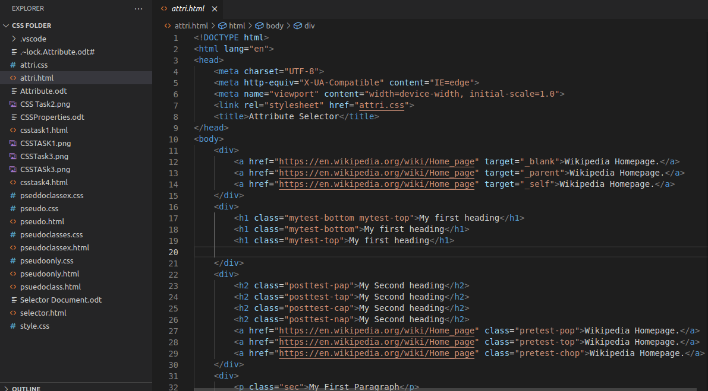

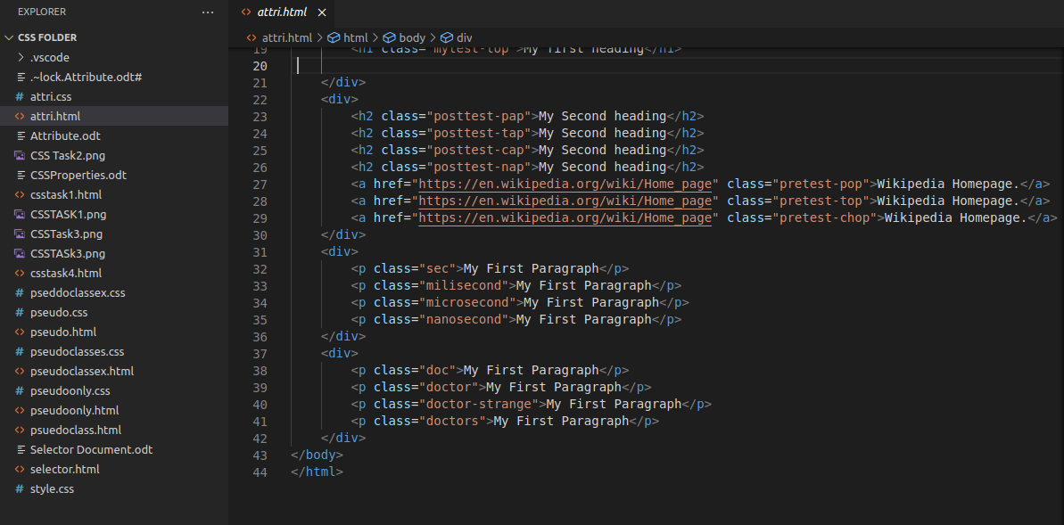
CSS CODE :
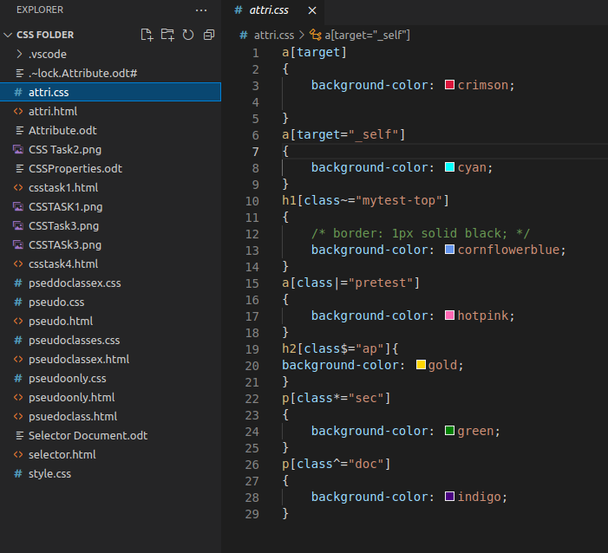

SCREENSHOT:
